Quick Guide Photocurrentsampling PCB

PCB Version Dec. 2023

PCB Layout

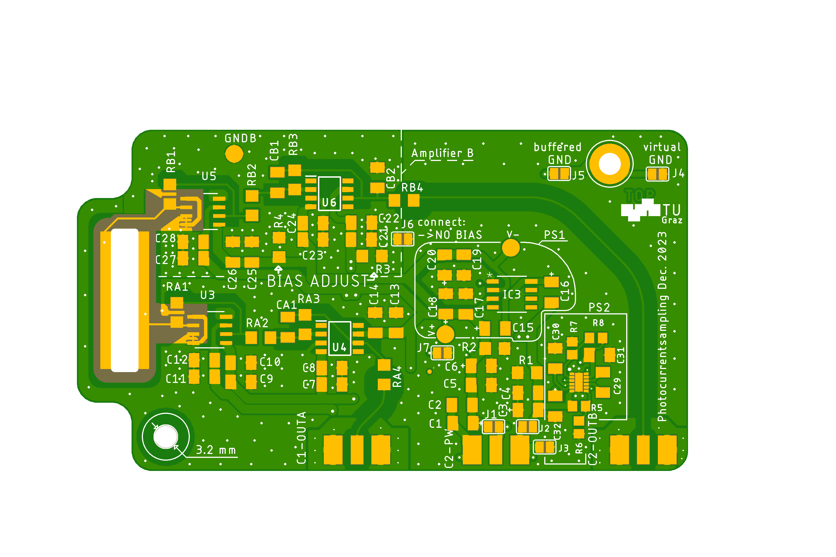

Electrode A

Electrode B

Output Amplifier A Power Connection Output B or Bias Voltage

Each chapter of this quick guide contains all the information necessary to build and operate the circuit with the specific setting.

Standard setting with 2 amplifiers: 2

Standard setting with 1 Amplifiers + external bias: 4

Standard setting with 2 amplifiers and static bias 6

Other options 8

# Standard setting with 2 amplifiers:

~250 kHz bandwidth, DC-transimpedance of 10 MΩ, no bias between electrodes, currents of both A & B electrodes are measured.

Connect Power to the central SMA Jack. +2.5. V on the inner connector, -2.5 V on the outer side (shield). This is the same as 5V supply with positive center that is potential free, e.g. a battery or the low noise power supply described in ‘LN_PSU_documentation_en’.

The Signals are distortion free between +/- 2V but can reach up and down to the supply voltages. Terminate only with >= 1 kΩ. 1MΩ Inputs are fine without termination if the cables used are not too long.

The jumpers J4, J5 and J7 allow different grounding configurations, e.g. separating the input stage ground plane from the housing and SMA shield ground. More information on this is available in the full documentation ‘PCS_double_documentation_en’. A configuration that always works, but may be not the best solution in terms of noise is closing (connecting) jumper J4, J5 and J7.

Table 1: Bill of materials for measurement on both electrodes, ~250 kHz bandwidth, DC-transimpedance of 10 MΩ, no bias between electrodes

| Qty | Value | Device | Package | Parts | Description | Hersteller Nr. |
| --- | --- | --- | --- | --- | --- | --- |
| 2 | 10M | R-EU_R1206 | R1206 | RA1, RB1 | Precision, thinfilm or metalfilm | ERA8AEB105V / MCA1206MD1005BP100 |
| 2 | 10k | R-EU_R1206 | R1206 | RA2, RB2 | 2nd Stage amplification feedback resistor |  |
| 2 | 10k | R-EU_R1206 | R1206 | RA3, RB3 | 2nd Stage amplification feedback resistor |  |
| 2 | 22pF | C-EUC1206K | C1206K | CA1, CB1 | NP0 feedback ceramic cap. |  |
| 2 | 50R | R-EU_R1206 | R1206 | RA4, RB4 | 47R-53R impedance matching resistor |  |
| 13 | 100n | C-EUC1206K | C1206K | C2, C4, C5, C7, C9, C11, C13, C17, C19, C21, C23, C25, C27 | 10% 50V X7R | C1206C104K5RACAUTO |
| 4 | 10n | C-EUC1206K | C1206K | C10, C12, C26, C28 | 10% 50V X7R | C1206C103K5RACTU |
| 9 | 10uF | C-EU_POL / C-EUC1206K | C1206K | C8, C14, C22, C24, C1, C3, C6, C18, C20 | Tantal electrolytic capacitor 1206 | TPSA106K010R0900 |
| 4 | 1k | R-EU_R1206 | R1206 | R1, R2, R3, R4 | Precision 1k 0.1% (metalfilm, thinfilm) | ERA8AEB102V |
| 2 | LTC6268HS8-10 | LTC6268HS8-10 | SO-8_S-L | U3, U5 |  |  |
| 2 | OPA380AID | OPA380AID | SOIC | U4, U6 | Texas Instruments OPA380AI | OPA380AID |
| 3 | SMA Jack | 73251-2123 |  | C1-OUTA, C2-OUTB, C2-PW | SMA Jack PCB Edge Mount 50 | 526-5785 |
| 2 | 1u | C-EU_POL | C1206K | C15, C16 | Tantal electrolytic capacitor 1206 | TPSA105K035R3000 |
| 1 | TLE2426 | TLE2426CDD8-M | D8-M | IC3 |  |  |
| 6 | () | Jumper PS1 |  | J1=y, J2=y, J3=n, J4 OR J5, J7=IF J4 AND J5 | Select appropriate Jumpers |  |
| 1 | () | Jumper Amp A & B |  | J6=y | Select appropriate Jumpers |  |

# Standard setting with 1 Amplifiers + external bias:

~250 kHz bandwidth, DC-transimpedance of 10 MΩ, current of A electrode is measured, connector B is bias input.

Connect Power to the central SMA Jack. +2.5 V on the inner connector, -2.5 V on the outer side (shield). This is the same as 5V supply with positive center that is potential free, e.g. a battery or the low noise power supply described in LN_PSU_documentation_en.

The Signal is on the Left connector (A). It is distortion free between +/- 2V but can reach up and down to the supply voltages. Terminate only with >= 1 kΩ. 1MΩ Inputs are fine without termination if the cables used are not too long.

The jumpers J4, J5 and J7 allow different grounding configurations, e.g. separating the input stage ground plane from the housing and SMA shield ground. More information on this is available in the full documentation ‘PCS_double_documentation_en’. A configuration that always works, but may be not the best solution in terms of noise is closing (connecting) jumper J4, J5 and J7.

Bias can be applied to the rightmost connector (B). The shield of the connector is grounded, the inner contact carries the bias voltage. It should stay within 100V and within the voltage rating of CB2. The bias signal is lowpass-filtered by CB2 and RB4 if RB4 is not 0R.

The corner frequency of this RC lowpass is calculated by following formula:

$$f_{-3db}=\frac{1}{2π R_{B4} C_{B2}}$$

The reason for the lowpass filter is to reduce high frequency noise that would create a current between the electrodes, because they form a plate capacitor. If the bias voltage will be modulated, it is important to choose a corner frequency that is much higher than the modulation frequency.

Table 2: Bill of materials for measurement on one electrode and external bias, ~250 kHz bandwidth, DC-transimpedance of 10 MΩ, bias supplied on connector B

|  |  |  |  |  |  |  |
| --- | --- | --- | --- | --- | --- | --- |
| **Qty** | **Value** | **Device** | **Package** | **Parts** | **Description** | **Hersteller Nr.** |
| 2 | 10M | R-EU_R1206 | R1206 | RA1 | Precision, thinfilm or metalfilm | ERA8AEB105V / MCA1206MD1005BP100 |
| 2 | 10k | R-EU_R1206 | R1206 | RA2 | 2nd Stage amplification feedback resistor |  |
| 2 | 10k | R-EU_R1206 | R1206 | RA3 | 2nd Stage amplification feedback resistor |  |
| 1 | 100nF C0G | C-EUC1206K | C1206K | CB2 | Bias Low Pass filter if no Amp2 installed |  |
| 2 | 22pF | C-EUC1206K | C1206K | CA1 | NP0 feedback ceramic cap. |  |
| 4 | 0R |  | 1206 | RB1, RB2, RB3 | 0R Jumpers or solder bridges |  |
|  | 0R – 10k |  | 1206 | RB4 | Bias lowpass together with CB2 or just 0R when no Lowpass is needed |  |
| 2 | 50R | R-EU_R1206 | R1206 | RA4 | 47R-53R impedance matching resistor |  |
| 13 | 100n | C-EUC1206K | C1206K | C2, C4, C5, C7, C9, C11, C13, C17, C19, C21, C23, C25, C27 | 10% 50V X7R | C1206C104K5RACAUTO |
| 4 | 10n | C-EUC1206K | C1206K | C10, C12, C26, C28 | 10% 50V X7R | C1206C103K5RACTU |
| 9 | 10uF | C-EU_POL / C-EUC1206K | C1206K | C8, C14, C22, C24, C1, C3, C6, C18, C20 | Tantal electrolytic capacitor 1206 | TPSA106K010R0900 |
| 4 | 1k | R-EU_R1206 | R1206 | R1, R2, R3, R4 | Precision 1k 0.1% (Metalfilm, Thinfilm) | ERA8AEB102V |
| 2 | LTC6268HS8-10 | LTC6268HS8-10 | SO-8_S-L | U3, U5 |  | LTC6268HS8-10 |
| 2 | OPA380AID | OPA380AID | SOIC | U4, U6 | Texas Instruments OPA380AI | OPA380AID |
| 3 | SMA Jack | 73251-2123 | 73251-2123 | C1-OUTA, C2-OUTB, C2-PW | SMA Jack PCB Edge Mount 50 | 526-5785 |
| 2 | 1u | C-EU_POL | C1206K | C15, C16 | Tantal electrolytic capacitor 1206 | TPSA105K035R3000 |
| 1 | TLE2426 | TLE2426CDD8-M | D8-M | IC3 |  | TLE2426CDD8-M |
| 7 | () | Jumper |  | J1, J2, J3, J4, J5, J6, J7 | Select appropriate Jumpers |  |
| 6 | () | Jumper PS1 |  | J1=y, J2=y, J3=n, J4 OR J5, J7=IF J4 AND J5 | Select appropriate Jumpers |  |
| 1 | () | Jumper Amp A & ext. Bias |  | J6=y | Select appropriate Jumpers |  |

# Standard setting with 2 amplifiers and static bias

To achieve a static bias voltage between the electrodes, the input of amplifier B (LTC6268-10) is held at that bias voltage. The voltage is set by resistor R3 and R4 which form a voltage divider between +2.5V and -2.5V. The bias voltage is also added to the output signal of amplifier B, therefore reducing the available voltage swing in one direction while increasing it in the other direction.

$$U_{bias B}=\frac{R_{4}}{R_{4}+R_{3}}⋅5 V-2.5 V$$

Scale R3 and R4 so that their parallel resistance is approximately 500 Ω.

$$\frac{R_{3}⋅R_{4}}{R_{3}+R_{4}}≈500 Ω$$

In the same way, a static bias can be applied to the A electrode, but only if jumper J4 and J7 are open.

$$U_{bias A}=\frac{R_{1}}{R_{1}+R_{2}}⋅5 V-2.5 V$$

Connect Power to the central SMA Jack. +2.5 V on the inner connector, -2.5 V on the outer side (shield). This is the same as 5V supply with positive center that is potential free, e.g. a battery or the low noise power supply described in ‘LN_PSU_documentation_en’.

The Signals are distortion free between +/- 2V but can reach up and down to the supply voltages. Terminate only with >= 1 kΩ. 1MΩ Inputs are fine without termination if the cables used are not too long.

The jumpers J4, J5 and J7 allow different grounding configurations, e.g. separating the input stage ground plane from the housing and SMA shield ground. More information on this is available in the full documentation ‘PCS_double_documentation_en’. A configuration that always works, but may be not the best solution in terms of noise is closing (connecting) jumper J4, J5 and J7. For static bias jumper J6 must always be open, therefore amplifier B will be surrounded by a virtual ground regardless of J4, J5 and J7.

Table 3: Bill of materials for measurement on both electrodes, ~250 kHz bandwidth, DC-transimpedance of 10 MΩ, static bias between electrodes

|  |  |  |  |  |  |  |
| --- | --- | --- | --- | --- | --- | --- |
| Qty | Value | Device | Package | Parts | Description | Hersteller Nr. |
| 2 | 10M | R-EU_R1206 | R1206 | RA1, RB1 | Precision, thinfilm or metalfilm | ERA8AEB105V / MCA1206MD1005BP100 |
| 2 | 10k | R-EU_R1206 | R1206 | RA2, RB2 | 2nd Stage amplification feedback resistor |  |
| 2 | 10k | R-EU_R1206 | R1206 | RA3, RB3 | 2nd Stage amplification feedback resistor |  |
| 2 | 22pF | C-EUC1206K | C1206K | CA1, CB1 | NP0 feedback ceramic cap. |  |
| 2 | 50R | R-EU_R1206 | R1206 | RA4, RB4 | 47R-53R impedance matching resistor |  |
| 13 | 100n | C-EUC1206K | C1206K | C2, C4, C5, C7, C9, C11, C13, C17, C19, C21, C23, C25, C27 | 10% 50V X7R | C1206C104K5RACAUTO |
| 4 | 10n | C-EUC1206K | C1206K | C10, C12, C26, C28 | 10% 50V X7R | C1206C103K5RACTU |
| 9 | 10uF | C-EU_POL / C-EUC1206K | C1206K | C8, C14, C22, C24, C1, C3, C6, C18, C20 | Tantal electrolytic capacitor 1206 | TPSA106K010R0900 |
| 4 | from formula / 1k | R-EU_R1206 | R1206 | R1, R2, R3, R4 | Precision 1k 0.1% (metalfilm, thinfilm) | ERA8AEB102V |
| 2 | LTC6268HS8-10 | LTC6268HS8-10 | SO-8_S-L | U3, U5 |  |  |
| 2 | OPA380AID | OPA380AID | SOIC | U4, U6 | Texas Instruments OPA380AI | OPA380AID |
| 3 | SMA Jack | 73251-2123 | 73251-2123 | C1-OUTA, C2-OUTB, C2-PW | SMA Jack PCB Edge Mount 50 | 526-5785 |
| 2 | 1u | C-EU_POL | C1206K | C15, C16 | Tantal electrolytic capacitor 1206 | TPSA105K035R3000 |
| 1 | TLE2426 | TLE2426CDD8-M | D8-M | IC3 |  |  |
| 6 | () | Jumper PS1 |  | J1=y, J2=y, J3=n, J4 OR J5, J7=IF J4 AND J5 | Select appropriate Jumpers |  |
| 1 | () | Jumper no static bias |  | J6=n | Select appropriate Jumpers |  |

# Other options

Additional configurations are possible using the same PCB. Options include:

* other transimpedance values
* higher or lower bandwidth
* single sided power supply

a detailed description of these options and a guide how to populate the PCB if those options are chosen is available in the full documentation ‘PCS_double_documentation_en’.